EN VILLE

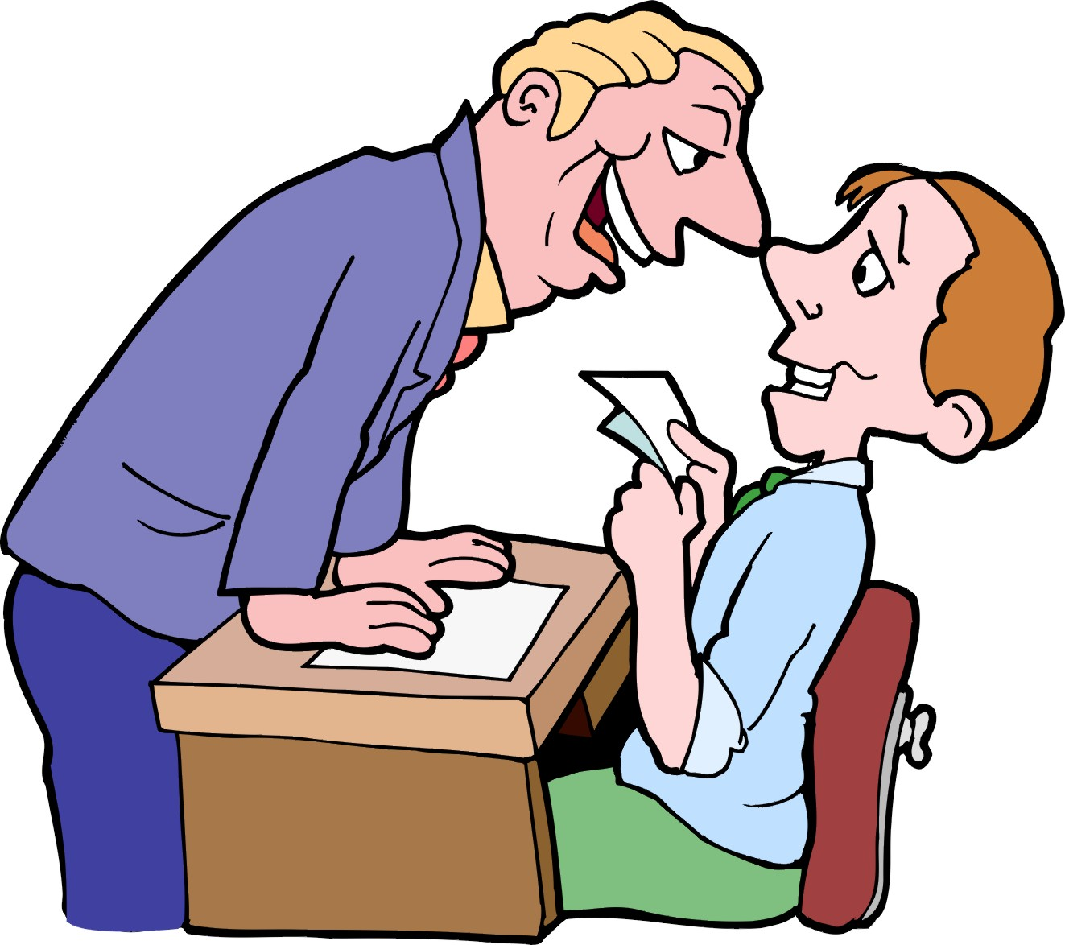
You are in town and you ask a passer by the following:

- Ask where the post office is.
- Say that it is not far.
- Ask if it is open.
- Ask what time it closes.
- Ask if you can buy postcards there.
- Ask how much a postcard costs.
- Say that it is cheap

DANS LA RUE

You are visiting a French town and ask a passer-by a few questions. The role of the passer-by will be played by the examiner. You must:

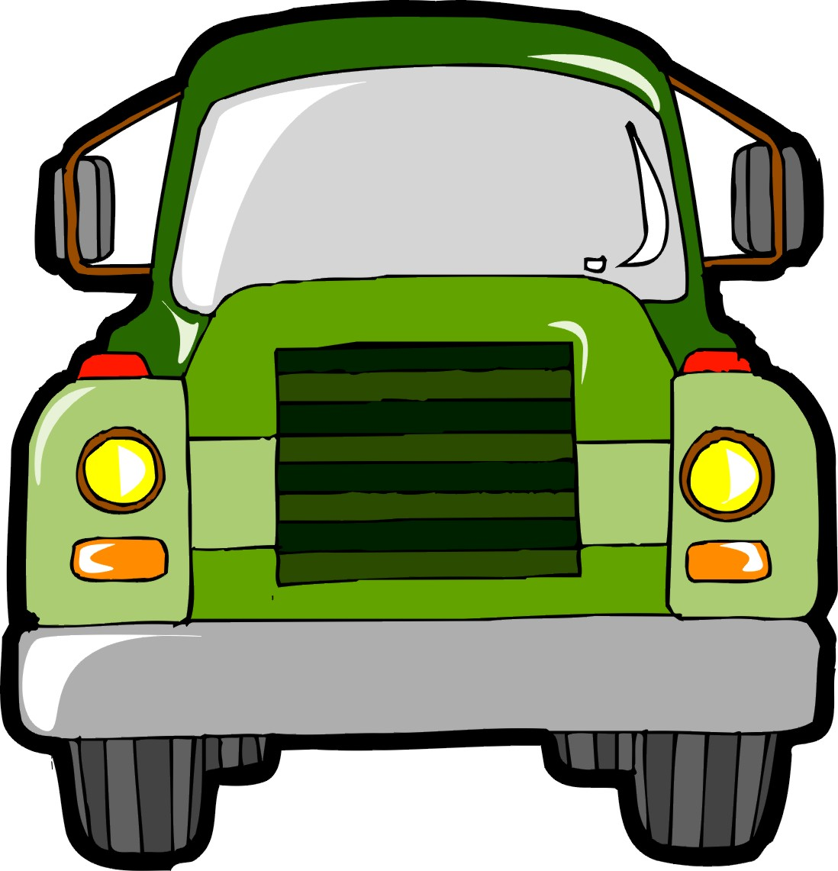
- Apologise and ask the way to the town centre.
- say that you are on foot
- ask where the bus stop is
- ask where you must get off
- thank him / her and say that he / she is very kind.
- day that you are spending a week here
- say that you are staying at your penfriend’s

A LA PISCINE

You are at a French swimming pool with your little sister. The role of the attendant will be played by the examiner. You must:
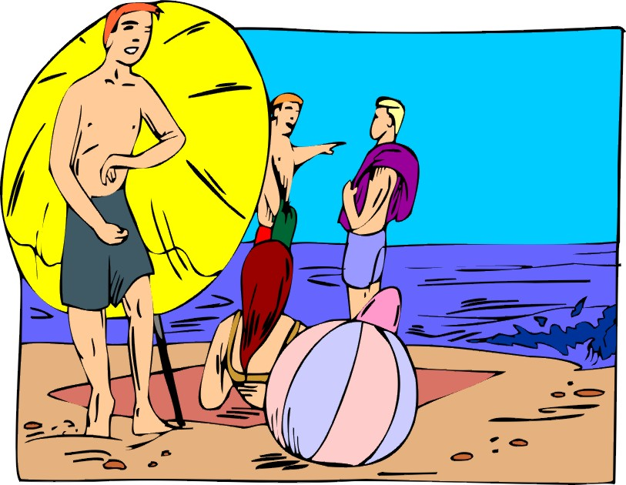
- ask how much it is
- ask if your sister must pay
- say that she is four years old
- ask at what time the pool closes
- say that you would like one ticket, please
- ask if the water is warm
- ask if you can play with a ball

AU CAMPING

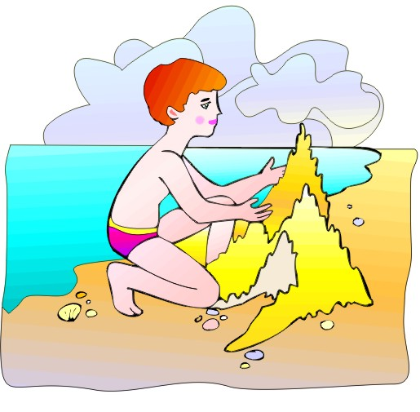
You have arrived at a campsite in France with your parents whi do not speak French. The part of the camp site receptionist will be played by the examiner. You must:

- say that your parents do not speak french
- say that you have a car and two tents
- say that you want to stay for three weeks
- ask how much it is per day
- ask if there are a lot of people in the camp site
- say that there are a lot of trees

ROUEN


You are staying in Rouen where you French friend lives and you ask your friend anout the town. The part of your friend will be played by your teacher. You must:

- ask if it is a big town
- ask how many people live in Rouen
- ask the name of the river in Rouen
- ask what the main monuments are
- ask if it far from Paris
- ask if there is a big market
- say that you would like to visit the town centre.

OFFICE DE TOURISME

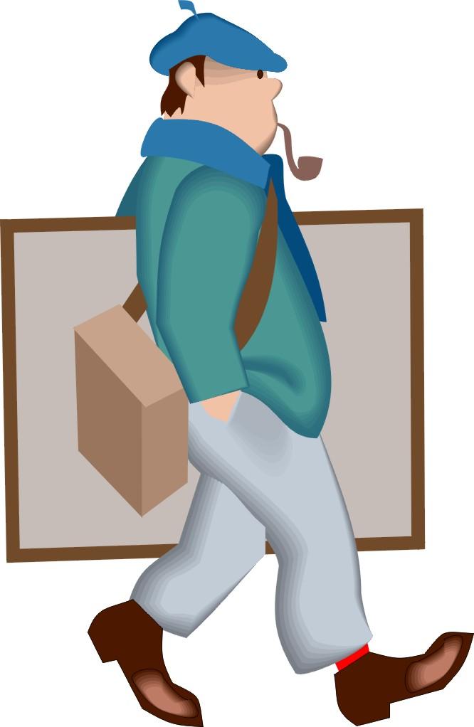
A dialogue between you and the official (played by the examiner) in the tourist office in a French town:

- ask if the tourist office is open
- ask if there is a good hotel nearby
- say that you want an hotel near the beach
- ask if it is expensive
- ask how to get to the hotel des dunes
- thank him / her and ask when the restaurants open
- ask where you can buy a sandwhich.

